# *Programming IV (420-B42-HR)*

# *Lab 8 – Robust Database Code*

Date assigned: Monday, April 10, 2017

Date due: **Monday, April 10, 2017, 11:00 a.m.**

**Learning Objectives**

Upon successful completion of this lab exercise, the student will be able to:

* Create Robust Code

Lab Set-Up

1. Make sure you name the controls properly. See the Moodle page for standards on how the controls are to be named.
2. Make sure that the multiple XAML files are linked together so that they are all available from a main page without having to restart the application.

To Do

In this lab the results are somewhat secondary to the fact that your code is robust. I am not going to detail to you what robust code means as we have talked about it, but want to see what you think it means to write robust code.

Yes, I am expecting you to create correct results, but I am really looking for robustness.

**Part A – Calculations on Database Code**

1. In this lab you are going to create some mathematical solutions based on database queries of the Chinook database. Create a solution called usernameB42L08. It can be a WPF solution; however, you will be creating other projects within it first.
2. The Chinook database is access with the username chinook and the password p4ssw0rd. You can also use these credentials to attach to the database is SQL Developer. Add a data source to access the Chinook tables: Artist, Album, Track, Genre, Media Type, Playlist and PlaylistTrack. You will not need this data source, but can use it if you like. You are creating it so you will see what the layout of the tables is. I have also included a table layout at the bottom of the lab.
3. Add a class library to your project called L08BLL.
4. Create appropriate classes for the Chinook database for the following methods:
   1. A method to calculate the total price for a requested album. The total price is calculated as the cost of all the tracks plus a 10% surcharge on that cost.
   2. A method to calculate the total price for all the tracks by a given artist. The total price is calculated as the cost of all the tracks plus a 10% surcharge on that cost.
   3. A method to calculate the total playing time for the tracks on a given Album. This method returns a string with the total time expressed as mm:ss. (minutes:seconds).
   4. A method to calculate the average playing time for the tracks on a given Album. This method returns a string with the average time expressed as mm:ss. (minutes:seconds).
   5. A method that returns the number of tracks on an album

NOTE: You may (likely will) need other methods too.

1. Create a new class library project in the solution called L08DB. You have your choice with this part. You can use the dataset and queries in the dataset or develop the methods directly in the DB class. The choice is yours.
2. You have Add datasets/queries or DB methods as follows:
   1. Return the Artist Name and Album Name for a given Album
   2. Return the total price of all the tracks for a requested Album Title.
   3. Return the total price of all the tracks for a requested Artist Name.
   4. Return the total playing time for a requested Album Title. The playing time of each track is listed, in milliseconds, in the Track table.
   5. Return the total number of tracks for a requested Album Title.

Regardless of the approach used, each of these queries should be a separate method in the class library with an appropriate name. This will be your data access layer. The methods could have the last two characters of DB to indicate that they access the database.

1. Returning to the WPF project, create a simple XAML page which allows the user to enter or select an album name (NOT case sensitive) and select if they want:
   1. The price of the album
   2. The total playing time of an album with number of tracks
   3. The average playing time for an album

If you wish to have the person select an artist first and then an album that is fine.

REMEMBER ROBUST CODE IS THE IMPORTANT THING HERE!

The Chinook Database Tables:

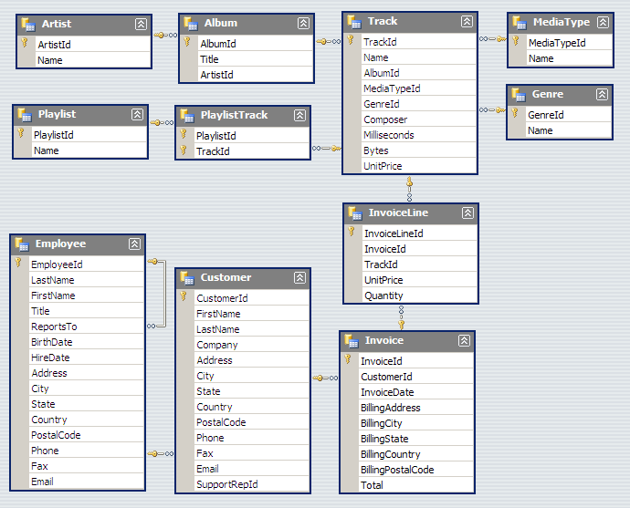

**To submit**

When you have completed the lab exercise, SHOW ME THE RESULTS and create a single zip file called YourUserNameB42L08.zip and copy the file to the Moodle page for the course.